<http://www2.lawrence.edu/fast/GREGGJ/CMSC250/git/github.html>

**Create a repository for your project**

To create a git repository on github for your own project, follow these instructions.

1. Go to github.com/new and enter a name for your repository. Click the "Create Repository" button.
2. After creating the repository, make a note of the repository URL.
3. Create a new project in NetBeans, or open an existing project. Right-click on the project and select Versioning/Initialize Git Repository... This will create a local repository for your project. (By default, NetBeans will put this repository in your project folder.

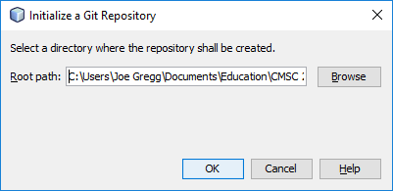

1. Right-click on the project again and select the option Git/Commit... to commit your project's current source code to the local repository.
2. Right-click on the project again and select Git/Remote/Push... to push your project to the remote repository on github.com. Put the repository URL you got from github in the dialog as depicted below.

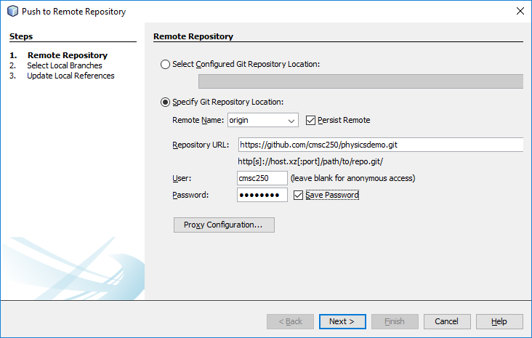

**Fetch the project from the github repository**

In NetBeans, select Git/Clone... from the Team menu.

Enter the github URL for your project along with the account user name and password.

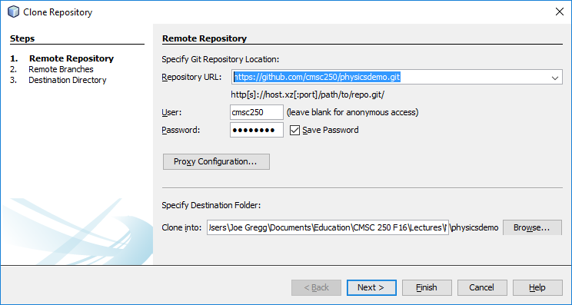

NetBeans will prompt you for a location on your local drive to clone the project to.

**Commit changes to the repository**

Once you have placed a project under version control, NetBeans will automatically track any changes you make to the project.

As you make changes, you can commit those changes to the local repository by selecting Commit... from the Team menu. Periodically you should also push your changes to the remote repository by selecting Remote/Push.. from the Team menu.

If members of your group have pushed changes to github, you can download those changes to your NetBeans project by selecting Remote/Pull... from the Team menu.

<https://netbeans.org/kb/docs/ide/git.html>